How Cardiac CT Testing Helps You: Insights from Butler Medical Imaging. (08) 9544 3999

[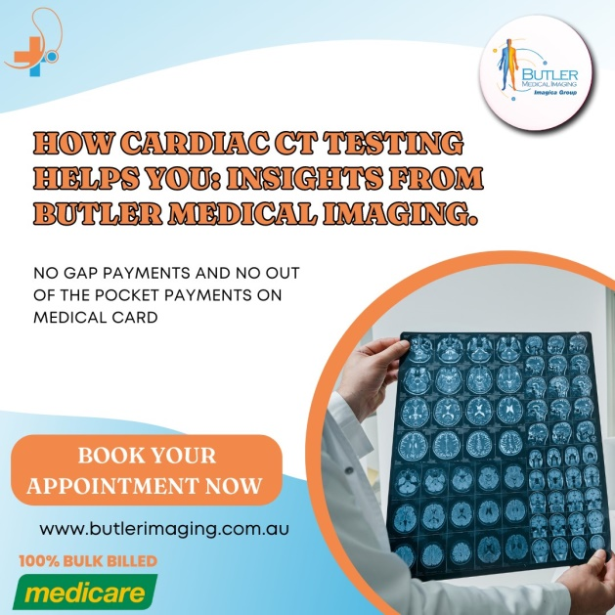](https://butlerimaging.com.au/ct-cardiac/)When it comes to understanding what's going on with your heart, sometimes the best approach is to take a closer look inside. One of the most effective tools we have for examining the heart is a computed tomography (CT) scan. [Cardiac](https://butlerimaging.com.au/ct-cardiac/) CT provides a detailed view of your heart’s anatomy, enabling doctors to identify various conditions and diseases that might be affecting your heart’s health.

**What Is a Cardiac CT Scan?**

A Cardiac CT scan is a specialized X-ray imaging technique designed to capture detailed images of your heart and its blood vessels. Unlike traditional X-rays that produce a single image, a Cardiac CT scan takes hundreds of images from different angles, allowing the creation of a comprehensive, three-dimensional model of your heart. This high-resolution imaging technique can reveal a wide range of issues that could impact your heart health.

**What Can a Cardiac CT Detect?**

Cardiac CT is incredibly useful in diagnosing several [heart-related](https://butlerimaging.com.au/ct-cardiac/) conditions. Some of the key issues that a Cardiac CT can detect include:

1. **Plaque Build-Up in the Coronary Arteries:** Plaque is a combination of fat, cholesterol, and other substances that can accumulate in the walls of your arteries. Over time, this build-up can narrow the arteries, reducing blood flow to your heart, which can lead to conditions like coronary artery disease or even a heart attack. A [Cardiac CT](https://butlerimaging.com.au/ct-cardiac/) can accurately measure the amount of plaque in your arteries, providing critical information for managing your heart health.
2. **Blood Clots in the Heart Chambers:** Blood clots that form inside the heart can lead to serious complications, including stroke. Cardiac CT can help locate these clots, allowing for timely intervention to prevent further complications.
3. **Tumours in or Around the Heart:** Although rare, tumours can develop in or around the heart. Cardiac CT is effective in detecting these growths, whether they are benign or malignant, enabling early diagnosis and treatment.
4. **Congenital Heart Disease:** Some people are born with heart defects that can affect their health throughout life. Cardiac CT is a valuable tool for identifying these congenital conditions, even if they have not caused symptoms before. Early detection can lead to better management and treatment of these conditions.

**How Cardiac CT Works?**

Most people are familiar with the concept of X-rays, where a single image is taken of a specific area of the body. Cardiac CT builds on this technology but takes it to a much more advanced level.

During a Cardiac CT scan, you’ll lie on a table that slides into a tube-shaped machine known as a gantry. The gantry houses the X-ray scanner, which rotates around your body, capturing images from multiple angles. These images are then processed by powerful computers to create a detailed, three-dimensional model of your heart.

This [3D model](https://butlerimaging.com.au/ct-cardiac/) allows doctors to see not just the surface of your heart, but also the intricate structures within it, including blood vessels, chambers, and valves. The ability to visualize your heart in such detail makes Cardiac CT a powerful tool for diagnosing heart conditions that might not be visible with other imaging techniques.

**Why Cardiac CT Is Useful?**

One of the challenges in imaging the heart is that it’s constantly in motion. Traditional X-rays require the patient to stay perfectly still to capture a clear image, but you can’t ask the heart to stop beating.

Cardiac CT overcomes this challenge by taking [multiple](https://butlerimaging.com.au/ct-cardiac/) images of the heart in rapid succession. By piecing together these images, the technology can create a dynamic, moving picture of the heart, allowing doctors to observe how it functions in real time. This ability to watch the heart at work is crucial for identifying problems that might not be evident when the heart is at rest.

For instance, Cardiac CT can help detect blockages in the coronary arteries, assess the severity of heart valve problems, and evaluate the effectiveness of previous heart surgeries or treatments. It can also be used to plan procedures such as angioplasty or bypass surgery by providing a detailed roadmap of the heart's structure.

**Conclusion**

Cardiac CT is a valuable tool in modern medicine, offering a non-invasive way to gain detailed insights into your heart’s health. By providing clear, [three-dimensional](https://butlerimaging.com.au/ct-cardiac/) images of your heart and its structures, Cardiac CT can help diagnose a wide range of heart conditions, guide treatment decisions, and monitor the effectiveness of ongoing therapies. If your doctor recommends a Cardiac CT scan, you can be confident that it will provide critical information to help manage and protect your heart health.

**Why Choose Butler Medical Imaging?**

We are local and a privately-owned medical clinics that offers the highest quality medical and Imaging Services in the [Butler Medical Imaging](https://butlerimaging.com.au/appointment/) region. We are the leaders in Bulk Billing with the real benefit of no ‘Out of Pocket’ expenses for you.

**Your Next Step**

Please ensure that you have your Medicare card and referral with you and pop into our location for your consultation. If you have any questions at all, please feel free to contact us at [+61 8 9544 3999](https://butlerimaging.com.au/appointment/) as we are here to help.